1.2.5

**Procedure Questions**

7a. I think “set Ball1.PaintColor to” changes the ball to a random color when the program is started

7b. “currentColor” represents the color of the ball

7c. “colorsClicked” represents the colors that are no longer going to be used because they have already been clicked.

7d. There will not be any colors clicked when the program starts

8. The operation PaintColor cannot accept the arguments: [(-16777216 -10747084 -9049804 -16760069 -12598621)]  
*Note:* You will not see another error reported for 5 seconds

9. RED_CHANNEL: Integer

Direction: Integer

10. Ball1.Heading: Integer

Ball1.Visible: Boolean

Canvas1.PaintColor: Color

12. Value ((non-coercible)) has wrong type (gnu.lists.PairWithPosition) (expected: real)

14. I think that when the 5th click is finished, the scores will not post and it will just be the Game Over screen

15. The ball continues to be visible and the Balls Left counter will continue to decrease with every click

16. The currentColor will only be one color and won’t change

17.

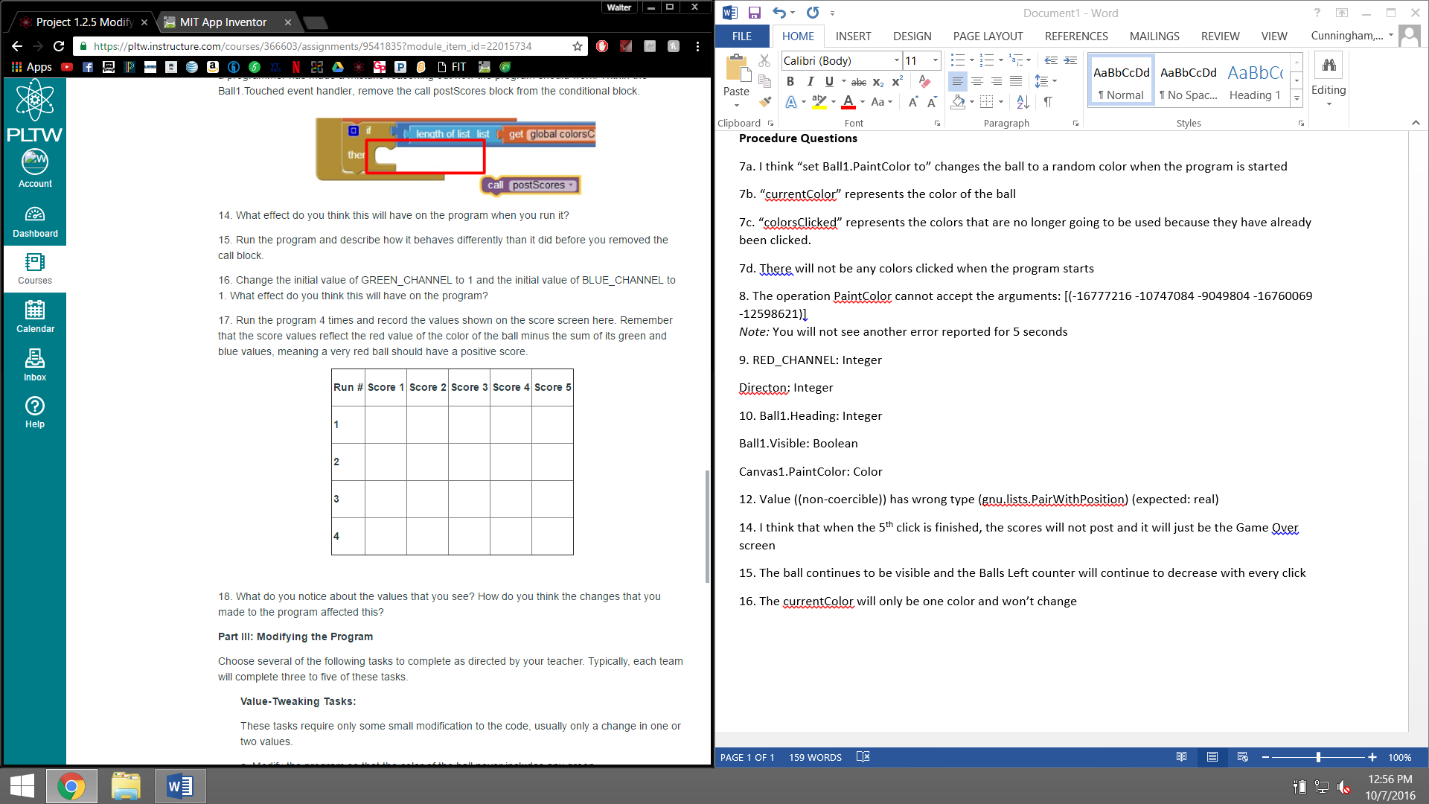

0 -240 -181 -181 -97

0 -110 -46 -95 -167

-181 -233 -88 -154 -54

0 -7 -96 -89 -122

18. All the values are negative. They changed it so there could only be different shades of red as currentColor.

**Conclusion Questions**

1a. I changed the direction of the ball so it goes to the left instead of the right when the program begins. The role of the variable (direction) is to set the path of the ball and move it towards a certain area of the screen.

1b. I changed the code so that when the ball hits one of the edges of the screen, it changes color. The role of the currentColor variable is to set the color of the ball at the present time

1c. I modified the code so that the ball was clicked 10 times before the game ended. The MAX_BALLS variable shows how many balls can be clicked before the game can end.

2.

* This affected my work by not allowing me to recognize quickly what each block of code’s purpose was. It made it take longer to understand the code as a whole.
* It helped by allowing me to reference each piece of code and know exactly what the purpose of it was even if I forgot
* It was hard to understand the code at first, but later on the code began to make more sense and modifying it became much easier
* The toughest challenge was probably just understanding the code and all the new variables. Everything we’ve done with this assignment is new to us and we are just beginning to understand the full potential of the program
* It allowed us to already have a steady foundation to work on and we didn’t have to create the program from scratch.
* Focusing on the small parts of code made getting the big picture of the program much easier

